**Multiple Discriminant Analysis**

**Group 5: MVA**

Multiple discriminant is a technique in which we require the dependent variable as categorical factors or levels in factor. When compared this to our dataset it is not applicable to our dataset because the dependent variable (y) i.e. Life expectancy in our case it contains metric(numeric) data. Hence, as discussed in the class the Multiple discriminant Analysis cannot be implemented.

In our dataset out target variable is Life Expectancy (dependent variable) and it is in numeric in nature and not a categorical data.

Therefore, Multiple Discriminant analysis cannot be applied to our dataset as for Multiple discriminant analysis the dependent variable column should be a categorical data or should have factors in levels.

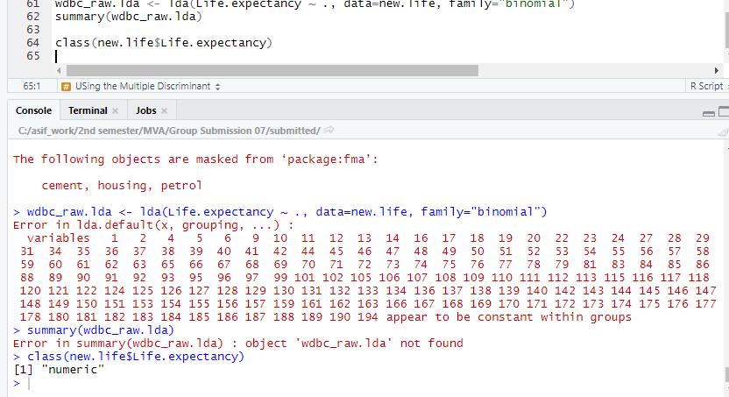

When we run the lda, we get this result in our case as Error. As the values associated with the dependent variable (Life.expectancy) are numeric.

**Therefore, we cannot apply logistic multiple discriminant technique to our analysis.**